# Consumption behaviours and poverty traps: A case study of detailed diary data from rural poor smallholder households in Uganda

## Appendix

**Table A1: Regression for expected income**

|  |  |  |  |  |  |  |
| --- | --- | --- | --- | --- | --- | --- |
|  | Lower performance estimation of expected income | | Central model (as presented in Table 4 in paper) | | Higher performance estimation of expected income | |
| Dep. Var: Weekly income (t) | Estimate (sd.) | Estimate (sd.) | | Estimate (sd.) | |
| Intercept | 4.595  (0.111) | 4.864***  (0.384) | | 6.699  (0.454) | |
| Income  (t-1) | 0.004  (0.015) | -0.057***  (0.017) | | -0.242  (0.018) | |
| Income  (t-2) | -0.095  (0.014) | -0.118***  (0.015) | | -0.243  (0.016) | |
| Consumption  (t-1) | 0.058  (0.017) | 0.044**  (0.018) | | 0.034  (0.021) | |
| Consumption  (t-2) | 0.016  (0.016) | 0.011  (0.017) | | 0.017  (0.02) | |
| Mean Parish Consumption  (t-1) |  | 0.144**  (0.062) | | 0.099  (0.064) | |
| Mean Parish Consumption  (t-2) |  | -0.102*  (0.054) | | -0.138  (0.058) | |
| Time trend | Quadratic | Quadratic | | Quartic | |
| R-squared | 0.435 | 0.519 | | 0.634 | |
| # households | 9262 | 421 | | 9262 | |
| Time periods used | 22 | 22 | | 22 | |
| Total # observations | 421 | 9262 | | 421 | |
| DW statistic | 2.01 | 2.06 | | 2.21 | |
| Barghava et al Durbin Watson Statistic | 2.01 | 2.06 | | 2.21 | |
| Baltagi-Wu LBI statistic | 2.07 | 2.12 | | 2.25 | |

**Table A2: Income reversion (non-persistence) for different specifications of unexpected income**

|  |  |  |  |  |  |  |
| --- | --- | --- | --- | --- | --- | --- |
|  | Low performance model for unexpected income | | Central estimator as presented in Table 5 of the paper) | | High performance model for unexpected income) | |
|  | $∆$ Expected Income | $∆$ Unexpected Income | $∆$ Expected Income | $∆$ Unexpected Income | $∆$ Expected Income | $∆$ Unexpected Income |
| Intercept | -0.325*** (0.021) | 0.019*** (0.012) | -0.331*** (0.022) | 0.023***  (0.01) | -0.275*** (0.024) | 0.013*** (0.007) |
| Dep. var. (t-1) | -0.566*** (0.016) | -0.629*** (0.008) | -0.567*** (0.014) | -0.652***  (0.008) | -0.515*** (0.015) | -0.671*** (0.008) |
| Dep. var. (t-2) | -0.47*** (0.011) | -0.388*** (0.007) | -0.431*** (0.012) | -0.432***  (0.008) | -0.381*** (0.013) | -0.496*** (0.008) |
| Dep. var. (t-3) | -0.246*** (0.01) | -0.209*** (0.008) | -0.218*** (0.01) | -0.249***  (0.008) | -0.119*** (0.012) | -0.325*** (0.008) |
| Dep. var. (t+1) | -0.419*** (0.011) | -0.481*** (0.004) | -0.439*** (0.009) | -0.488***  (0.004) | -0.365*** (0.01) | -0.511*** (0.005) |
| R-squared | 0.62 | 0.60 | 0.60 | 0.61 | 0.59 | 0.62 |
| # households | 421 | 421 | 421 | 421 | 421 | 421 |
| Time periods used | 17 | 17 | 17 | 17 | 17 | 17 |
| Total # observations | 7157 | 7157 | 7157 | 7157 | 7157 | 7157 |
| DW statistic | 1.37 | 1.22 | 1.36 | 1.25 | 1.4 | 1.33 |
| Barghava et al Durbin Watson Statistic | 1.37 | 1.22 | 1.36 | 1.25 | 1.4 | 1.33 |
| Baltagi-Wu LBI statistic | 1.48 | 1.31 | 1.47 | 1.33 | 1.52 | 1.38 |

Note: ‘ $∆$’ refers to the first difference of the respective variable

**Table A3: Reverse causality for different specifications of unexpected income**

|  |  |  |  |
| --- | --- | --- | --- |
|  | **Low performance model $∆$**  Unexpected Income | **Central model $∆$** Unexpected Income | **High performance model $∆$**  Unexpected Income |
| $∆$ Consumption(t-1) | -0.01 (0.01) | 0.00 (0.01) | 0.00 (0.01) |
| Controls? | Yes | Yes | Yes |
| R squared | 0.51 | 0.5 | 0.51 |
| # households | 421 | 421 | 421 |
| Time periods used | 20 | 20 | 20 |
| Total # observations | 8420 | 8460 | 8420 |
| DW statistic | 2.03 | 2.04 | 2.06 |
| Barghava et al Durbin Watson Statistic | 2.03 | 2.04 | 2.06 |
| Baltagi-Wu LBI statistic | 2.12 | 2.13 | 2.13 |

**Table A4: Results for ‘Rule of Thumb’ models with the ‘low’ performance measure of unexpected income**

|  |  |  |  |  |  |  |
| --- | --- | --- | --- | --- | --- | --- |
|  | Dep. Var: $∆$ Consumption | | Dep. Var: $∆$ Discretionary Consumption | | Dep. Var: $∆$ Flexible Consumption | |
| $∆$ Expected Income |  | 0.167** | 0.243** | 0.04 | 0.18* | 0.126 |
| *Std. Error* |  | 0.076 | 0.112 | 0.12 | 0.104 | 0.107 |
| $∆$ Expected Income (+ve values) |  | 0.12 | 0.141 | 0.385* | 0.361** | 0.261 |
| *Std. Error* |  | 0.124 | 0.186 | 0.213 | 0.175 | 0.175 |
| $∆$ Unexpected Income |  | 0.202*** | 0.317*** | 0.2*** | 0.354*** | 0.181*** |
| *Std. Error* |  | 0.032 | 0.053 | 0.056 | 0.048 | 0.049 |
| $∆$ Unexpected Income  (+ve values) |  | 0.17*** | 0.038 | 0.061 | 0.072 | 0.151* |
| *Std. Error* |  | 0.053 | 0.082 | 0.093 | 0.075 | 0.082 |
| Include Habits parameters? |  | Yes | No | Yes | No | Yes |
| Include 'Keeping Up' (KUJ) parameters? |  | Yes | No | Yes | No | Yes |
| R-squared |  | 0.77 | 0.43 | 0.71 | 0.45 | 0.77 |
| Number households |  | 421 | 421 | 421 | 421 | 421 |
| Number time periods (used) |  | 21 | 21 | 21 | 21 | 21 |
| Total used observations |  | 8841 | 8841 | 8841 | 8841 | 8841 |
| Durbin-Watson (DW) Statistic |  | 1.97 | 2.44 | 2.05 | 2.47 | 1.93 |
| Baltagi-Wu LBI statistic |  | 2.07 | 2.55 | 2.17 | 2.58 | 2.06 |
| Barghava et al DW Statistic |  | 1.97 | 2.44 | 2.05 | 2.47 | 1.93 |

**Table A5: Results for ‘Rule of Thumb’ models with the ‘high’ performance measure of unexpected income**

|  |  |  |  |  |  |  |
| --- | --- | --- | --- | --- | --- | --- |
|  | Dep. Var: $∆$ Consumption | | Dep. Var: $∆$ Discretionary Consumption | | Dep. Var: $∆$ Flexible Consumption | |
| $∆$ Expected Income |  | 0.203*** | 0.247*** | 0.142* | 0.371*** | 0.179** |
| *Std. Error* |  | 0.048 | 0.08 | 0.084 | 0.073 | 0.072 |
| $∆$ Expected Income (+ve values) |  | 0.098 | 0.102 | 0.148 | 0.014 | 0.129 |
| *Std. Error* |  | 0.083 | 0.13 | 0.142 | 0.119 | 0.119 |
| $∆$ Unexpected Income |  | 0.209*** | 0.291*** | 0.214*** | 0.339*** | 0.257*** |
| *Std. Error* |  | 0.037 | 0.059 | 0.064 | 0.056 | 0.056 |
| $∆$ Unexpected Income  (+ve values) |  | 0.128* | 0.04 | 0.048 | 0.058 | -0.003 |
| *Std. Error* |  | 0.067 | 0.1 | 0.113 | 0.09 | 0.1 |
| Include Habits parameters? |  | Yes | No | Yes | No | Yes |
| Include 'Keeping Up' (KUJ) parameters? |  | Yes | No | Yes | No | Yes |
| R-squared |  | 0.77 | 0.44 | 0.71 | 0.44 | 0.77 |
| Number households |  | 421 | 421 | 421 | 421 | 421 |
| Number time periods (used) |  | 21 | 21 | 21 | 21 | 21 |
| Total used observations |  | 8841 | 8841 | 8841 | 8841 | 8841 |
| Durbin-Watson (DW) Statistic |  | 1.95 | 2.42 | 2.03 | 2.48 | 1.94 |
| Baltagi-Wu LBI statistic |  | 2.04 | 2.53 | 2.14 | 2.58 | 2.05 |
| Barghava et al DW Statistic |  | 1.95 | 2.42 | 2.03 | 2.48 | 1.94 |

**Table A6: Results for ‘Habit formation’ models with the ‘low’ performance measure of unexpected income**

|  |  |  |  |  |  |  |
| --- | --- | --- | --- | --- | --- | --- |
|  | Dep. Var: $∆$  Consumption | | Dep. Var: $∆$ Discretionary Consumption | | Dep. Var: $∆$ Flexible Consumption | |
| $∆$ Consumption (t-1) | -0.499*** | -0.035 | -0.428*** | 0.009 | -0.599*** | -0.065** |
| *Std. Error* | 0.024 | 0.03 | 0.022 | 0.023 | 0.022 | 0.027 |
| $∆$ Consumption (t-1)  (+ve values) | 0.171*** | 0.081** | 0.099*** | 0.055 | 0.388*** | 0.141*** |
| *Std. Error* | 0.04 | 0.038 | 0.038 | 0.037 | 0.037 | 0.038 |
| Include ROT parameters? | No | Yes | No | Yes | No | Yes |
| Include KUJ parameters? | No | Yes | No | Yes | No | Yes |
| R-squared | 0.43 | 0.72 | 0.43 | 0.72 | 0.44 | 0.71 |
| Number households | 421 | 421 | 421 | 421 | 421 | 421 |
| Number time periods (used) | 21 | 21 | 21 | 21 | 21 | 21 |
| Total used observations | 8841 | 8841 | 8841 | 8841 | 8841 | 8841 |
| Durbin-Watson (DW) Statistic | 2.08 | 2.01 | 2.09 | 1.96 | 2.08 | 1.93 |
| Baltagi-Wu LBI statistic | 2.15 | 2.1 | 2.19 | 2.08 | 2.17 | 2.04 |
| Barghava et al DW Statistic | 2.08 | 2.01 | 2.09 | 1.96 | 2.08 | 1.93 |

**Table A7: Results for ‘Habit formation’ models with the ‘high’ performance measure of unexpected income**

|  |  |  |  |  |  |  |
| --- | --- | --- | --- | --- | --- | --- |
|  | Dep. Var: $∆$  Consumption | | Dep. Var: $∆$ Discretionary Consumption | | Dep. Var: $∆$ Flexible Consumption | |
| $∆$ Consumption (t-1) | -0.464*** | -0.034 | -0.423*** | 0.006 | -0.575*** | -0.079*** |
| *Std. Error* | 0.022 | 0.027 | 0.022 | 0.023 | 0.022 | 0.026 |
| $∆$ Consumption (t-1)  (+ve values) | 0.183*** | 0.069* | 0.093** | 0.031 | 0.367*** | 0.127*** |
| *Std. Error* | 0.039 | 0.038 | 0.037 | 0.035 | 0.037 | 0.037 |
| Include ROT parameters? | No | Yes | No | Yes | No | Yes |
| Include KUJ parameters? | No | Yes | No | Yes | No | Yes |
| R-squared | 0.46 | 0.72 | 0.45 | 0.72 | 0.46 | 0.72 |
| Number households | 421 | 421 | 421 | 421 | 421 | 421 |
| Number time periods (used) | 21 | 21 | 21 | 21 | 21 | 21 |
| Total used observations | 8841 | 8841 | 8841 | 8841 | 8841 | 8841 |
| Durbin-Watson (DW) Statistic | 2.11 | 2 | 2.08 | 1.95 | 2.07 | 1.93 |
| Baltagi-Wu LBI statistic | 2.19 | 2.08 | 2.18 | 2.05 | 2.17 | 2.03 |
| Barghava et al DW Statistic | 2.11 | 2 | 2.08 | 1.95 | 2.07 | 1.93 |

**Table A8: Results for ‘Keeping up with the Joneses’ models with the ‘low’ performance measure of unexpected income.**

|  |  |  |  |  |  |  |
| --- | --- | --- | --- | --- | --- | --- |
|  | Dep. Var: $∆$ Consumption | | Dep. Var: $∆$ Discretionary Consumption | | Dep. Var: $∆$ Flexible Consumption | |
| $∆$ Average parish consumption (t-1) | 0.692*** | 0.537*** | 0.863*** | 0.811*** | 0.851*** | 0.783*** |
| *Std. Error* | 0.033 | 0.038 | 0.017 | 0.02 | 0.018 | 0.02 |
| $∆$ Average parish consumption (t-1)  (+ve values) | 0.146*** | 0.204*** | -0.058*** | -0.032 | -0.016 | 0.006 |
| *Std. Error* | 0.048 | 0.053 | 0.021 | 0.034 | 0.022 | 0.035 |
| Include ROT parameters? | No | Yes | No | Yes | No | Yes |
| Include Habits parameters? | No | Yes | No | Yes | No | Yes |
| R-squared | 0.56 | 0.71 | 0.59 | 0.72 | 0.59 | 0.71 |
| Number households | 421 | 421 | 421 | 421 | 421 | 421 |
| Number time periods (used) | 21 | 21 | 21 | 21 | 21 | 21 |
| Total used observations | 8841 | 8841 | 8841 | 8841 | 8841 | 8841 |
| Durbin-Watson (DW) Statistic | 2 | 2.01 | 2 | 1.97 | 1.98 | 1.96 |
| Baltagi-Wu LBI statistic | 2.08 | 2.1 | 2.09 | 2.08 | 2.08 | 2.06 |
| Barghava et al DW Statistic | 2 | 2.01 | 2 | 1.97 | 1.98 | 1.96 |

Note: Expected Income changes were included as a control variable in all models

**Table A9: Results for ‘Keeping up with the Joneses’ models with the ‘high’ performance measure of unexpected income.**

|  |  |  |  |  |  |  |
| --- | --- | --- | --- | --- | --- | --- |
|  | Dep. Var: $∆$ Consumption | | Dep. Var: $∆$ Discretionary Consumption | | Dep. Var: $∆$ Flexible Consumption | |
| $∆$ Average parish consumption (t-1) | 0.648*** | 0.532*** | 0.827*** | 0.77*** | 0.811*** | 0.717*** |
| *Std. Error* | 0.033 | 0.035 | 0.017 | 0.019 | 0.018 | 0.02 |
| $∆$ Average parish consumption (t-1)  (+ve values) | 0.136*** | 0.159*** | -0.04* | -0.046 | -0.012 | 0.017 |
| *Std. Error* | 0.047 | 0.05 | 0.021 | 0.033 | 0.022 | 0.035 |
| Include ROT parameters? | No | Yes | No | Yes | No | Yes |
| Include Habits parameters? | No | Yes | No | Yes | No | Yes |
| R-squared | 0.57 | 0.71 | 0.6 | 0.71 | 0.6 | 0.71 |
| Number households | 421 | 421 | 421 | 421 | 421 | 421 |
| Number time periods (used) | 21 | 21 | 21 | 21 | 21 | 21 |
| Total used observations | 8841 | 8841 | 8841 | 8841 | 8841 | 8841 |
| Durbin-Watson (DW) Statistic | 2.01 | 2 | 1.98 | 1.96 | 1.98 | 1.94 |
| Baltagi-Wu LBI statistic | 2.09 | 2.08 | 2.08 | 2.06 | 2.07 | 2.04 |
| Barghava et al DW Statistic | 2.01 | 2 | 1.98 | 1.96 | 1.98 | 1.94 |

Note: Expected Income changes were included as a control variable in all models

## Simulation details under Rule of Thumb and Keeping up with the Joneses.

## Rationale and methods

Asymmetric behavioural responses to unexpected income shocks and parish level consumption suggests individuals fail to reduce consumption under negative shocks as much as they increase consumption under positive shocks. Assuming these shocks are distributed symmetrically with a mean of zero, these asymmetric Rule of Thumb and Keeping up with the Joneses behavioral patterns suggest poverty traps can arise where wealth is fails to accumulate or may decline over time.

Poverty traps arise when otherwise identical individuals or households experience bifurcating wealth dynamics depending on the starting endowments, and exogenous opportunities and constraints available to them (Balboni et al., 2022). Behavioural poverty traps can arise where shared behavioural traits and responses mean that some individuals with different opportunities and wealth endowments fail to accumulate wealth. For example, behavioural poverty traps have been identified as arising from non-linear costs of temptation (Banerjee and Mullainathan, 2010) and self-control (Bernheim et al., 2015).

We tested the existence and significance of behavioural patterns on household wealth accumulation and poverty traps through household wealth simulations for different behavioural pattern combinations. We modelled individual wealth dynamics through a weekly timestep. Simulated individuals were constructed from a randomly drawn starting asset levels, itself drawn from the distribution of assets owned by individuals from the sample of households surveyed for this study. Individuals in the model had expected income equal to a minimum per capita income, plus dividends from their endowment of productive assets. The minimum weekly income and dividends were calibrated to best match the distribution of expected income estimated for the sample of surveyed individuals. Unexpected income shocks were also drawn from the distribution of unexpected income estimated in Section 6 of the manuscript. The standard deviation was scaled based on the assets owned by the modelled individuals, inducing heteroskedasticity in unexpected income shocks based on the assumption that income derived from assets – such as farm production and business income - provides higher risks and rewards.

Behavioural parameters for Permanent Income Hypothesis, Rule of Thumb, and Keeping up with the Joneses were drawn from the distributions of estimated behavioural coefficients in Section 7 of the manuscript. This includes both the symmetric and asymmetric behavioural coefficients. The Rule of Thumb parameters defined how much consumption will respond to unexpected income, whereas the Keeping up with the Joneses coefficients defined how much consumption will respond to mean parish level incomes*.*

Mean parish income was calculated from the consumption across all modelled households if they were to follow consumption patterns expected by the permanent t income hypotheses with credit constraints. We assumed no credit is available, meaning individuals must consume from their income and savings alone.[1] Finally, we defined a minimum savings threshold equal to the 5% savings quintile of the sample. Modelled individuals that fall to this minimum savings threshold were assumed to only consume their expected income (i.e. spend as expected under the Permanent Income Hypothesis (PIH) with credit constraints and infinite time horizons).

In each weekly timestep, modelled individuals observed their expected and unexpected income, as well as their previous consumption and previous consumption for the parish for the ROT and KUJ simulations respectively, and make consumption decisions. This consumption decision is equal to expected income (of which is expected under the PIH with credit constraints with infinite time horizons), and the net changes to consumption due to their observed unexpected income and the parish level consumption in the previous period. Given the consumption decision, households will either save or consume out of their savings. After each year, individual asset levels are updated based on the savings levels of the last timestep. Expected and unexpected income distributions are updated yearly to reflect some stickiness and delay in the accumulation (or sale) and productivity of assets. Full details of the models are documented within the code-sets within the supplementary materials.

## Results

Figures A1 and A2 plot the loess regressions over the simulated current assets and three-year lagged assets for the different behavioural models, with and without the asymmetry. As expected, under the Permanent Income Hypothesis in Figure A1.1, individuals in the model did not consume more than they earn on average when consumption is based on their expected income. The Rule of Thumb with symmetry results resemble that of the Permanent Income Hypothesis (Figure A1.2). As households had perfect information about current and future expected income, and because weekly income shocks were stochastically drawn with a mean of zero, on average households retained their level of asset endowments between periods. Under asymmetric Rule of Thumb (Figure A1.3) however, households, on average, tended to retain consumption levels from previous periods during negative shocks more so than positive shocks, which resulted in a slight trend in asset decline between periods.

Keeping up with the Joneses (Figures A2.1 and A2.2) induced a behavioural poverty trap where asset levels trended towards either a high or low asset equilibrium. This occurred even when KUJ parameters were symmetric for positive and negative shocks. In combination with the PIH parameters, there existed an unstable equilibrium level of assets. Individuals below this unstable threshold consumed more to keep up with the perceived consumption of their peers under both positive and negative shocks to their income. Over time this resulted in a gradual reduction in asset levels as individuals had lower savings under positive shocks and consumed out of these savings under negative shocks. As KUJ behavioural patterns are in response to mean parish consumption levels, whereas ROT is in response to marginal changes to an individual’s income, KUJ behaviour results in larger deviations away from the asset dynamics. When introducing asymmetry, the poverty trap slightly widened as the unstable equilibrium shifts to a higher threshold and assets decline at a faster rate. After combining KUJ and ROT in the same model, the overall asset dynamics resemble that of the KUJ simulation without ROT, with the asymmetry model having a very slight drop in the unstable equilibrium due to the ROT behaviour.

**Figure A1: Asset dynamics and asset equilibria for key behavioral model results (Permanent income hypothesis and Rule of Thumb)**

A

B

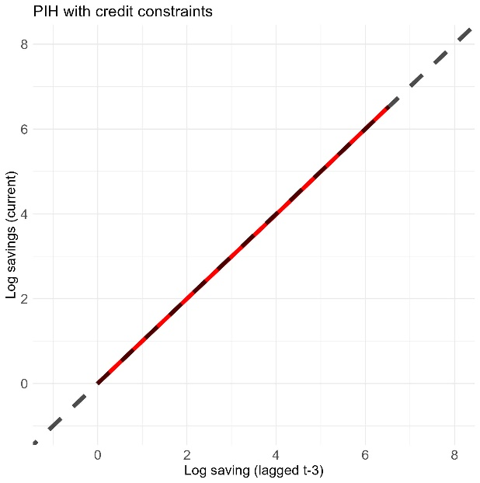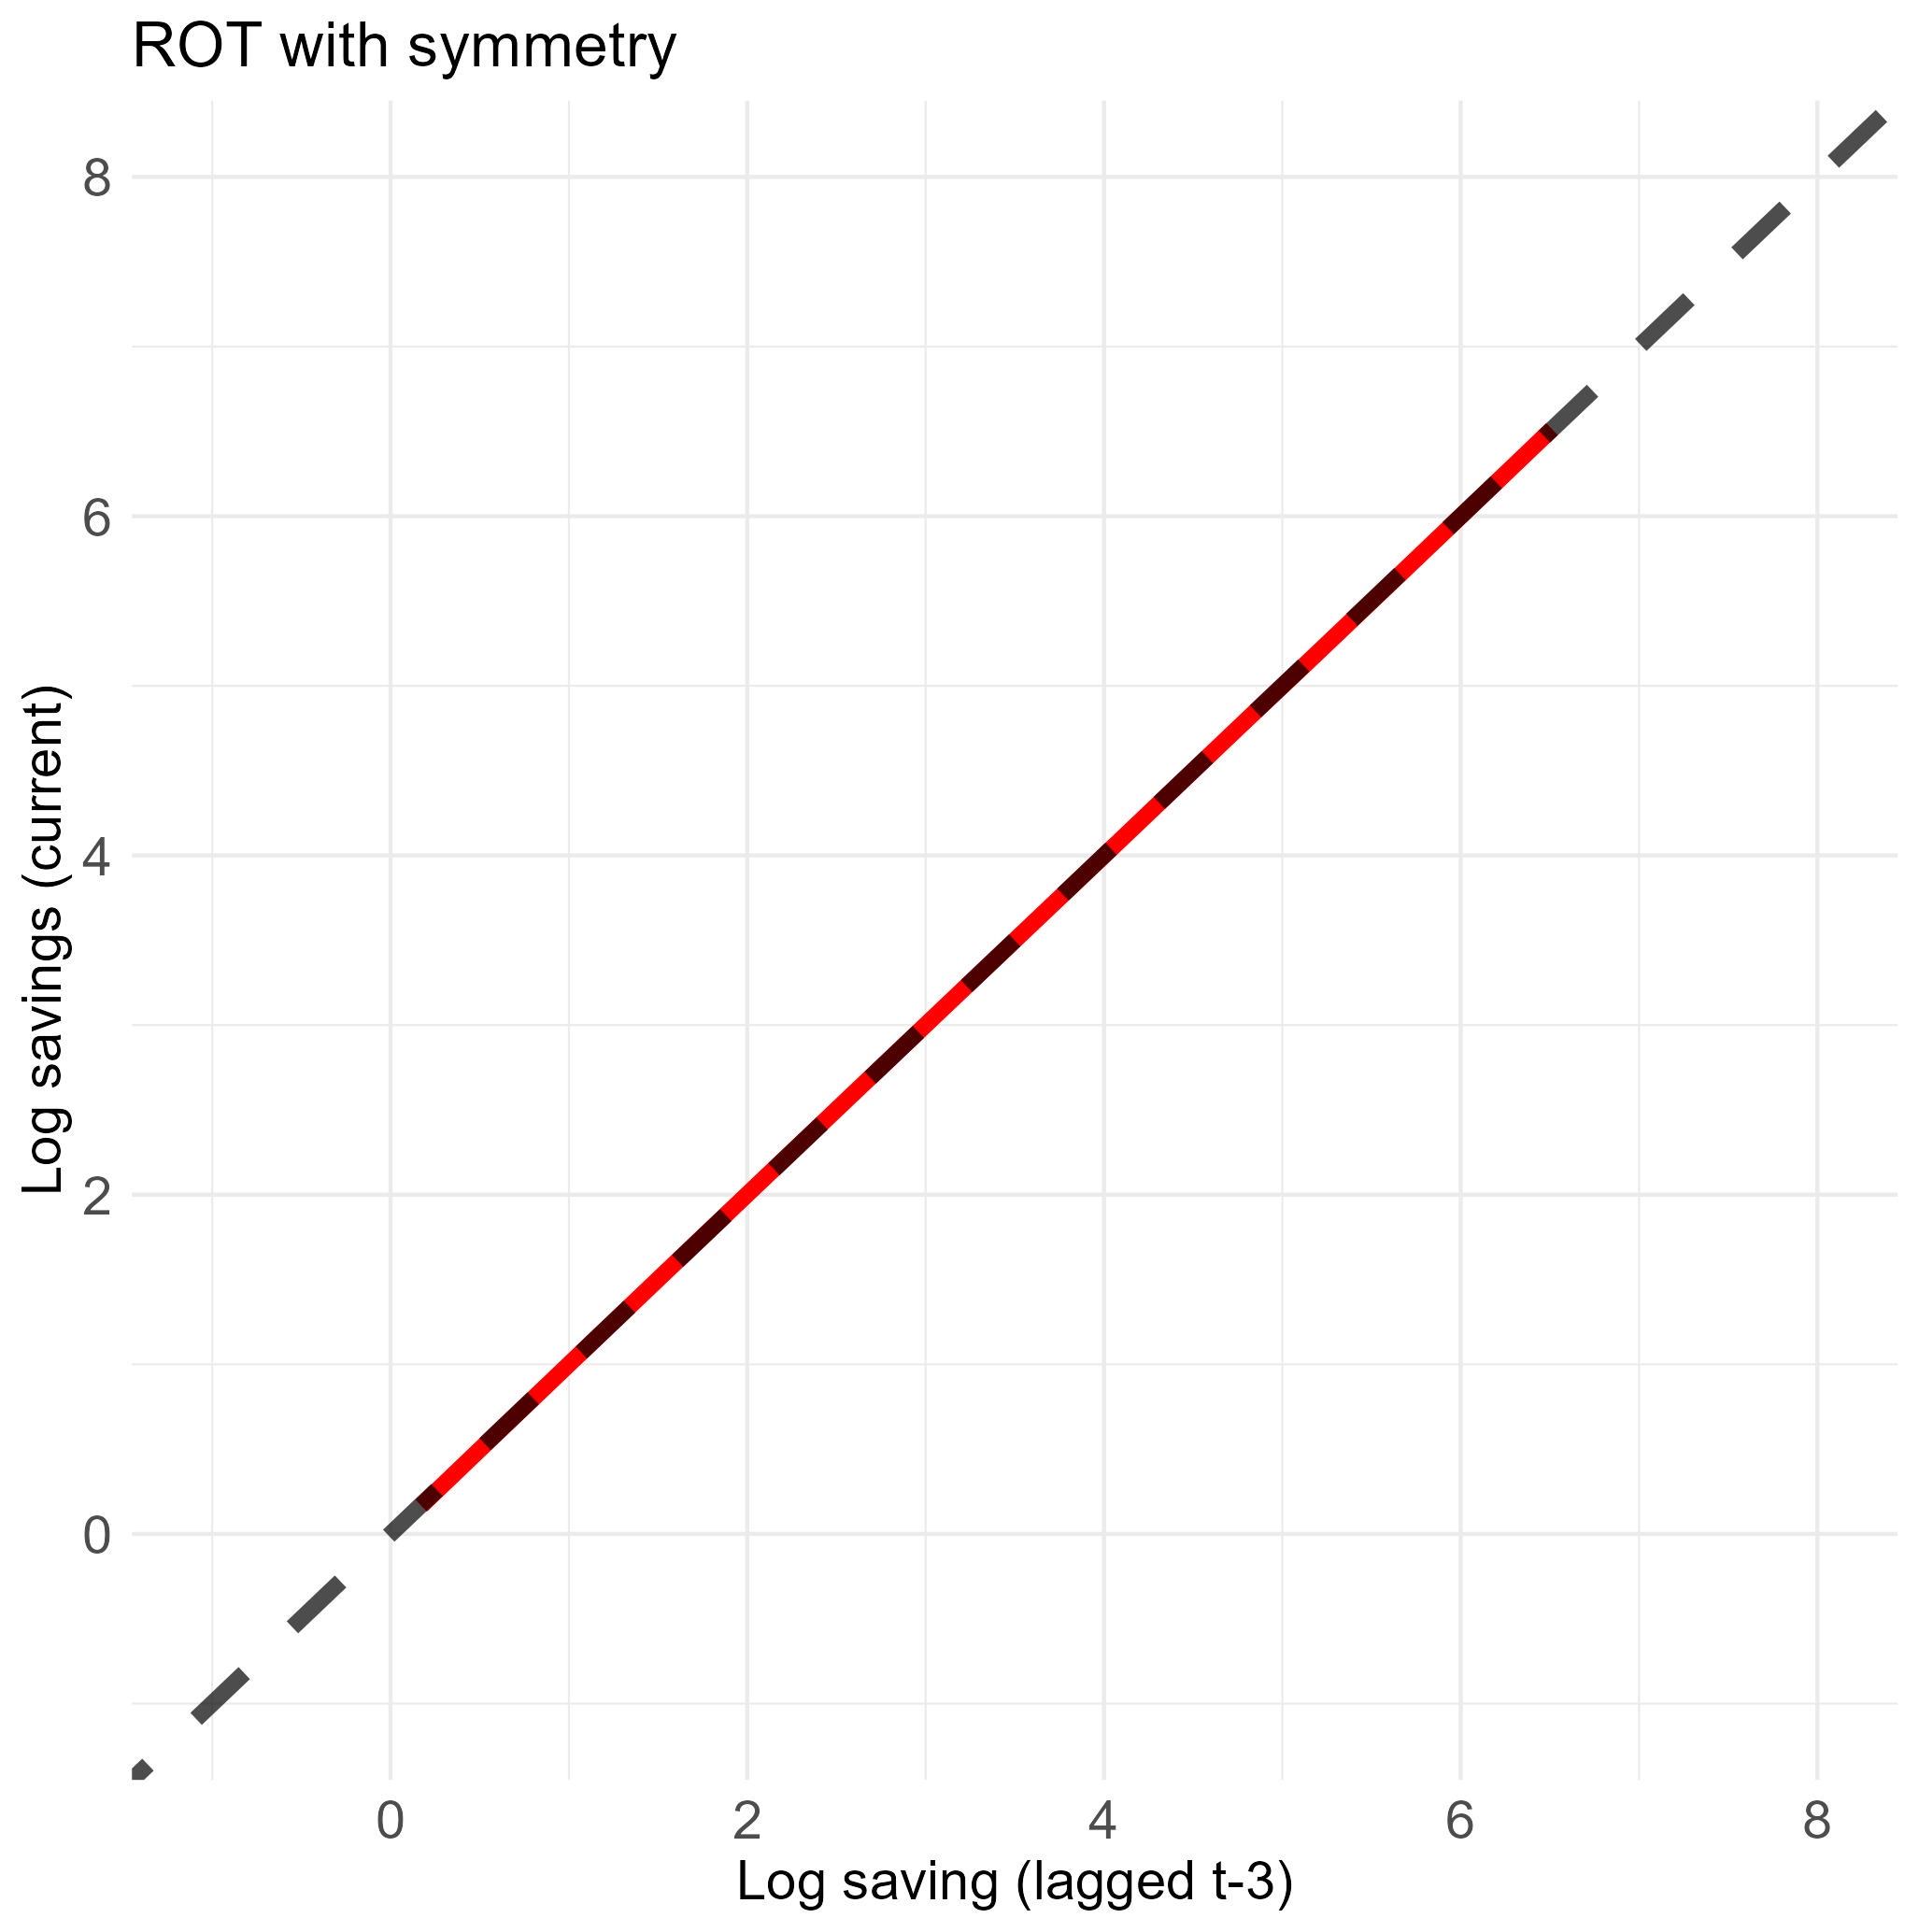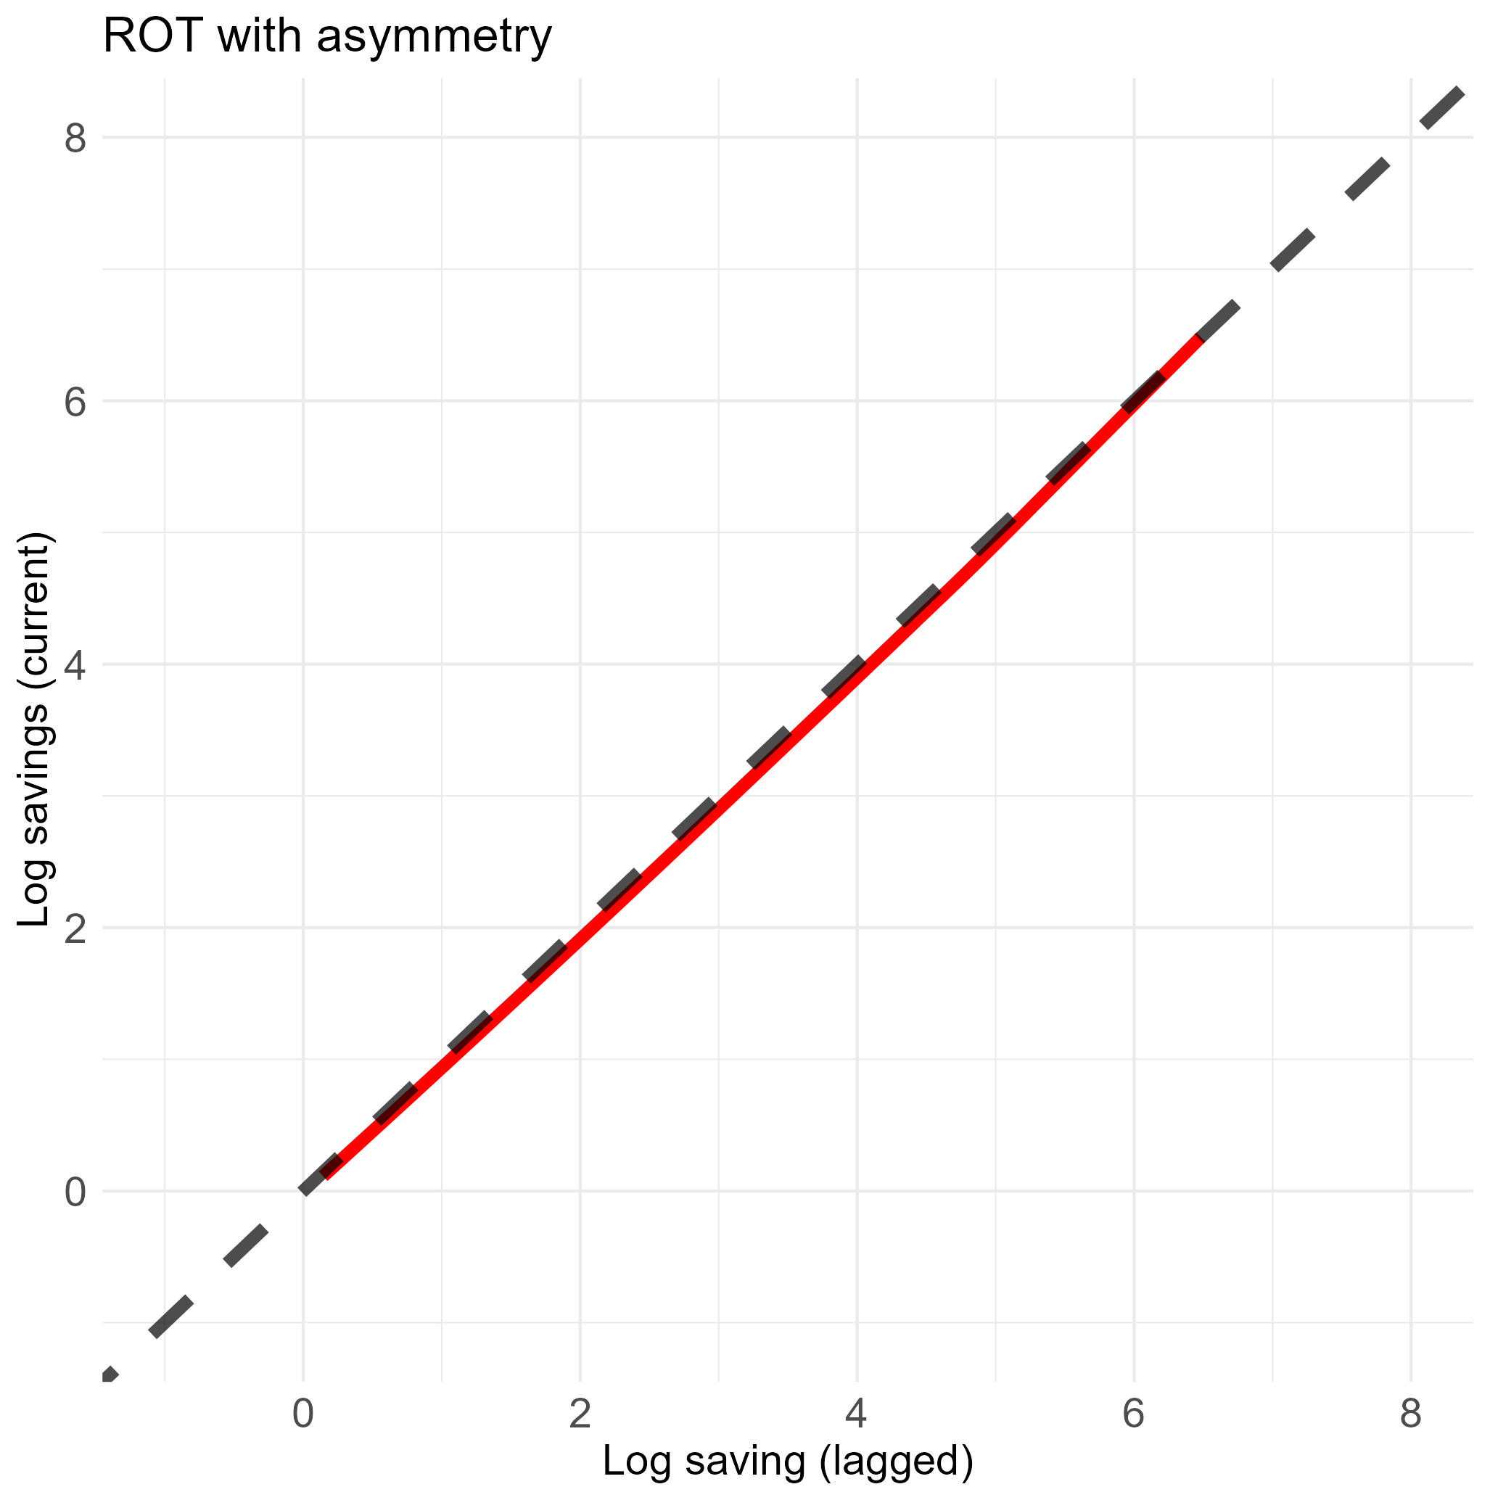

C

**Figure A2: Asset dynamics and asset equilibria for key behavioral model results (Keeping up with the Jones and all models combined)**

C

A

B

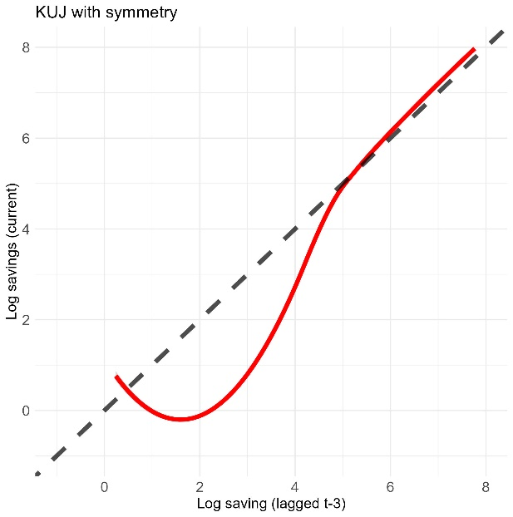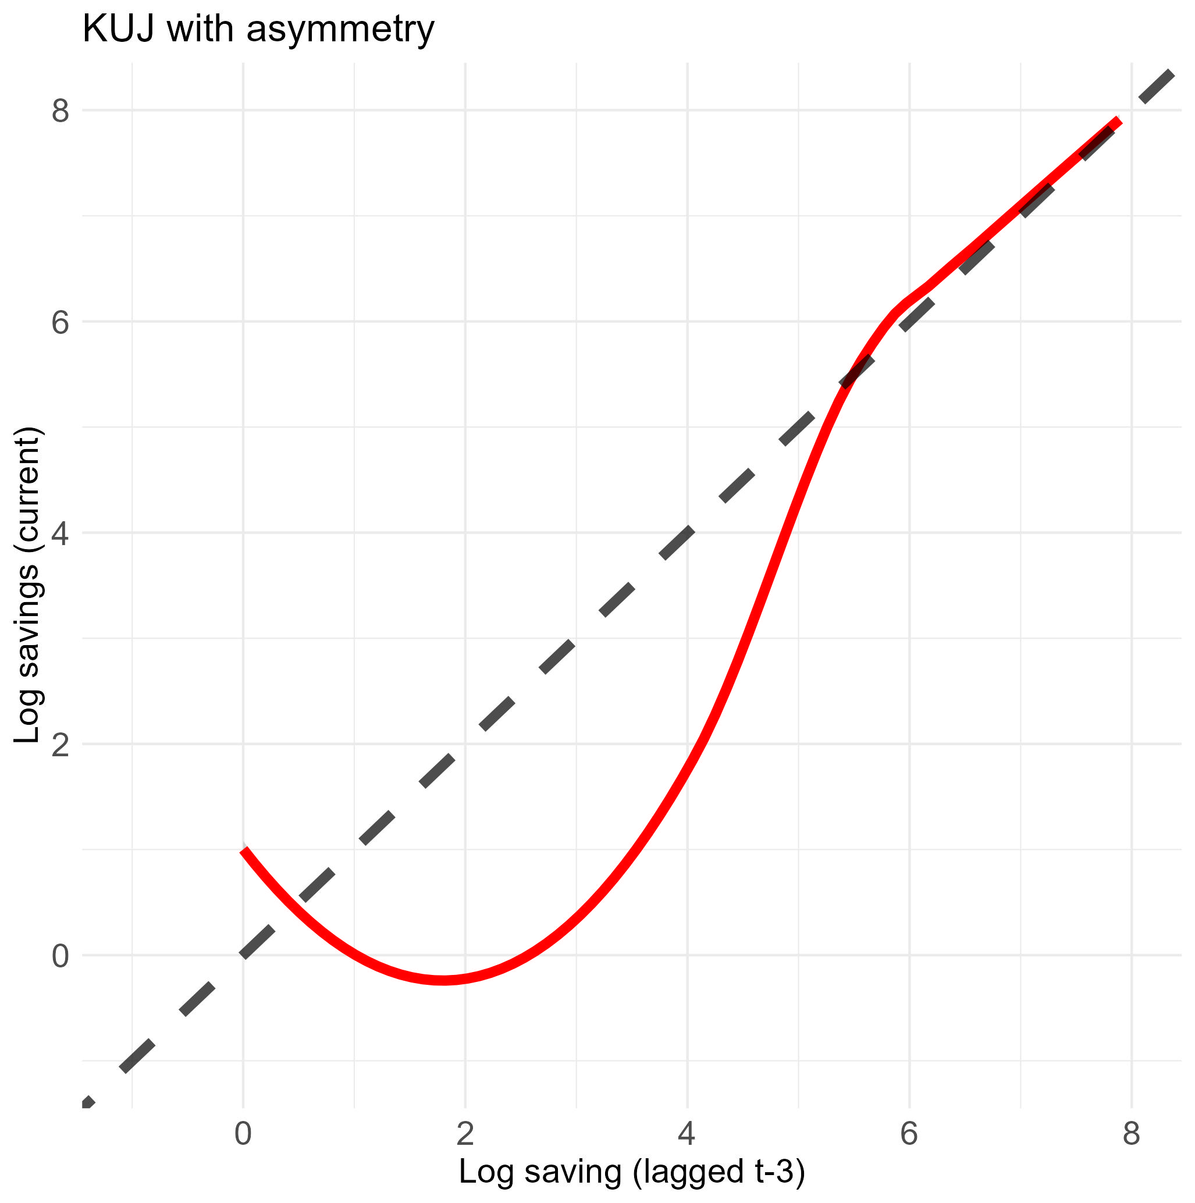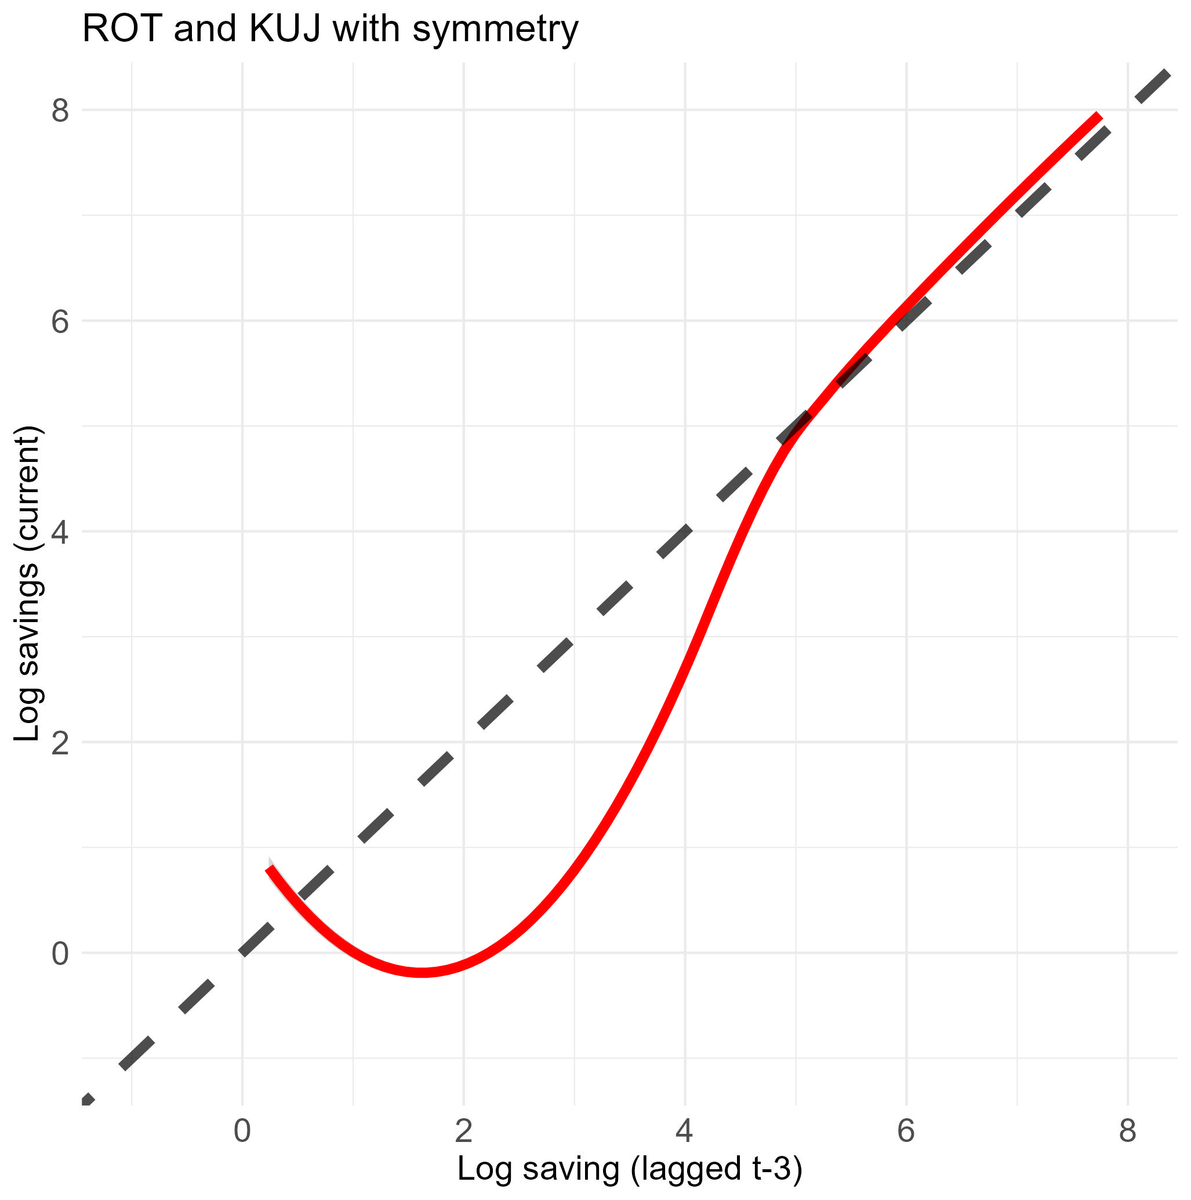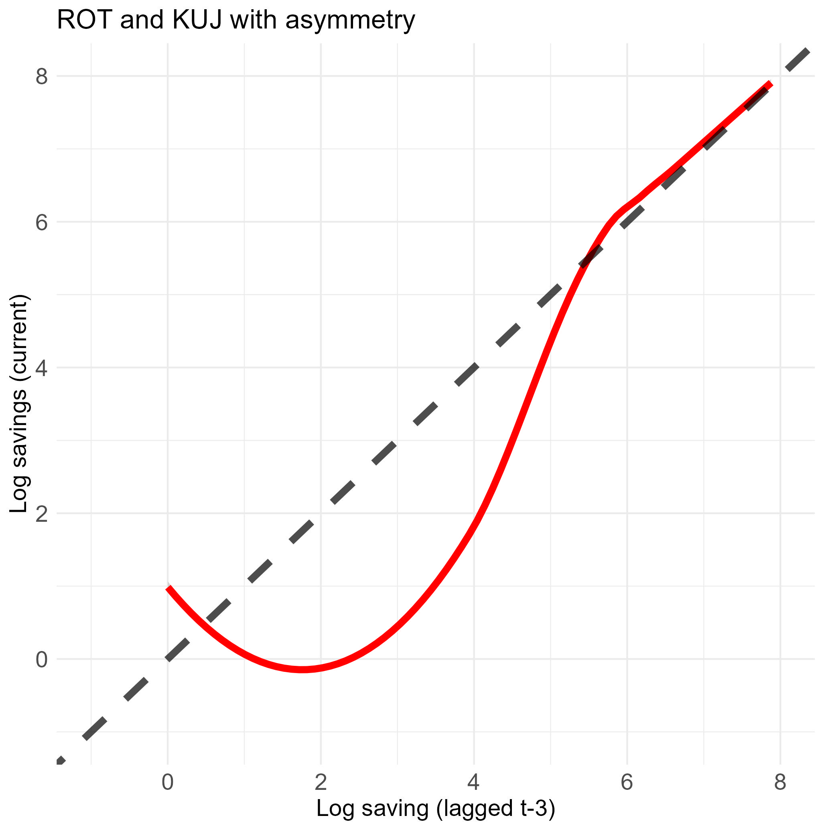

D

## References

Balboni, C., Bandiera, O., Burgess, R., Ghatak, M. & Heil, A. 2022. Why do people stay poor? *The Quarterly Journal of Economics,* 137**,** 785-844.

Banerjee, A. & Mullainathan, S. 2010. The shape of temptation: Implications for the economic lives of the poor. National Bureau of Economic Research.

Bernheim, B. D., Ray, D. & Yeltekin, Ş. 2015. Poverty and self‐control. *Econometrica,* 83**,** 1877-1911.`

1. Different credit constraint levels simply shift the modelled asset dynamic equilibria with no change in the overall shape and insights from the simulation.